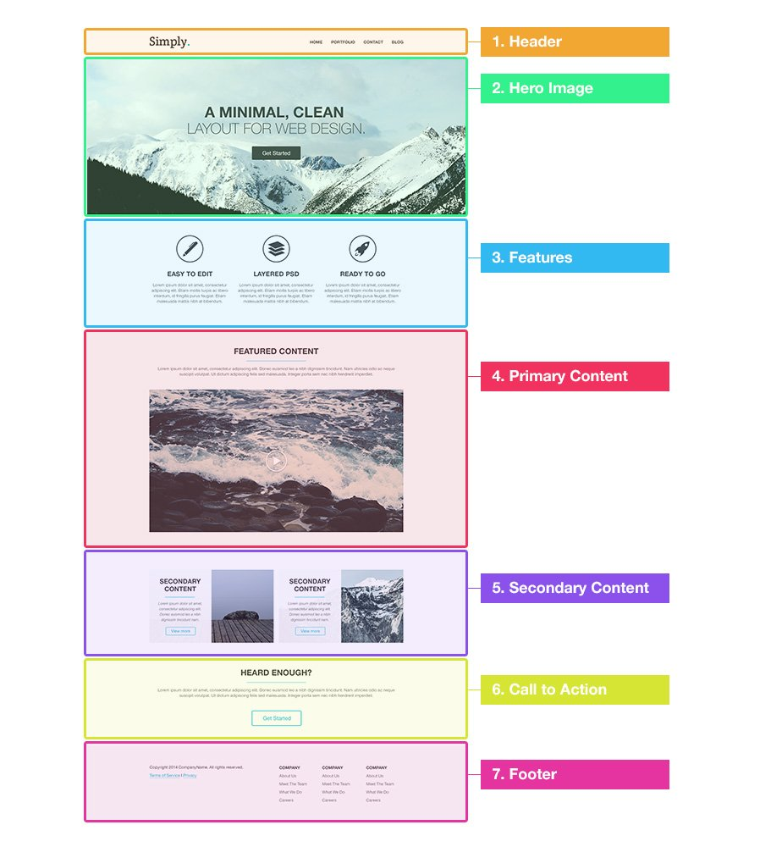

hero.jpg - 2000 x 697 px

features-icon-1.png - 100 x 100 px

features-icon-2.png - 100 x 100 px

features-icon-3.png - 100 x 100 px

video-placeholder.jpg - 940 x 527 px

article-image-1.jpg - 460 x 270 px

article-image-2.jpg - 460 x 270 px

**blue print like:**

<!DOCTYPE HTML>

<html>

<head>

<meta http-equiv="Content-Type" content="text/html; charset=utf-8">

<title>Simply</title>

<!--[if lt IE 9]>

<script src="http://html5shiv.googlecode.com/svn/trunk/html5.js"></script>

<![endif]-->

</head>

<body>

**<header>**

<div class="wrapper">

<h1></h1>

<nav></nav>

</div>

**</header>**

**<div id="hero-image">**

<div class="wrapper">

<h2></h2>

<a></a>

</div>

**</div>**

**<div id="features">**

<div class="wrapper">

<ul>

<li></li>

<li></li>

<li></li>

</ul>

</div>

**</div>**

**<div id="primary-content">**

<div class="wrapper">

<article></article>

</div>

**</div>**

**<div id="secondary-content">**

<div class="wrapper">

<article></article>

<article></article>

</div>

**</div>**

**<div id="cta">**

<div class="wrapper">

</div>

**</div>**

**<footer>**

<div class="wrapper">

<div id="footer-info"></div>

<div id="footer-links">

<ul></ul>

<ul></ul>

<ul></ul>

</div>

</div>

**</footer>**

</body>

</html>

/**********************************************

**Section 1: Header**

<header>

<div class="wrapper">

<h1>Simply<span class="color">.</span></h1>

<nav>

<ul>

<li><a href="#">Home</a></li>

<li><a href="#">Portfolio</a></li>

<li><a href="#">Contact</a></li>

<li><a href="#">Blog</a></li>

</ul>

</nav>

</div>

</header>

**Section 2: Hero Image**

<div id="hero-image">

<div class="wrapper">

<h2><strong>A Minimal, clean</strong><br/>

layout for web design.</h2>

<a href="#" class="button-1">Get Started</a>

</div>

</div>

**Section 3: Features**

<div id="features">

<div class="wrapper">

<ul>

<li class="feature-1">

<h4>Easy to Edit</h4>

<p>Lorem ipsum dolor sit amet, consectetur adipiscing elit. Etiam mollis turpis ac libero interdum, id fringilla purus feugiat. Etiam malesuada mattis nibh at bibendum.</p>

</li>

<li class="feature-2">

<h4>Layered PSD</h4>

<p>Lorem ipsum dolor sit amet, consectetur adipiscing elit. Etiam mollis turpis ac libero interdum, id fringilla purus feugiat. Etiam malesuada mattis nibh at bibendum.</p>

</li>

<li class="feature-3">

<h4>Ready to Go</h4>

<p>Lorem ipsum dolor sit amet, consectetur adipiscing elit. Etiam mollis turpis ac libero interdum, id fringilla purus feugiat. Etiam malesuada mattis nibh at bibendum.</p>

</li>

<div class="clear"></div>

</ul>

</div>

</div>

**Section 4: Primary Content**

<div id="primary-content">

<div class="wrapper">

<article>

<h3>Featured Content</h3>

<p>Lorem ipsum dolor sit amet, consectetur adipiscing elit. Donec euismod leo a nibh dignissim tincidunt. Nam ultricies odio ac neque suscipit volutpat. Ut dictum adipiscing felis sed malesuada. Integer porta sem nec nibh hendrerit imperdiet. </p>

<a href="#"><img src="images/video-placeholder.jpg" alt="video placeholder" /></a>

</article>

</div>

</div>

**Section 5: Secondary Content**

<div id="secondary-content">

<div class="wrapper">

<article style="background-image: url('images/article-image-1.jpg');">

<div class="overlay">

<h4>Secondary Content</h4>

<p><small>Lorem ipsum dolor sit amet, consectetur adipiscing elit. Donec euismod leo a nibh dignissim tincidunt nam.</small></p>

<a href="#" class="more-link">View more</a>

</div>

</article>

<article style="background-image: url('images/article-image-2.jpg');">

<div class="overlay">

<h4>Secondary Content</h4>

<p><small>Lorem ipsum dolor sit amet, consectetur adipiscing elit. Donec euismod leo a nibh dignissim tincidunt nam.</small></p>

<a href="#" class="more-link">View more</a>

</div>

</article><div class="clear"></div>

</div>

</div>

**Section 6: Call to Action**

<div id="cta">

<div class="wrapper">

<h3>Heard Enough?</h3>

<p>Lorem ipsum dolor sit amet, consectetur adipiscing elit. Donec euismod leo a nibh dignissim tincidunt. Nam ultricies odio ac neque suscipit volutpat. Ut dictum adipiscing felis sed malesuada. Integer porta sem nec nibh hendrerit imperdiet. </p>

<a href="#" class="button-2">Get Started</a>

</div>

</div>

**Section 7: Footer**

<footer>

<div class="wrapper">

<div id="footer-info">

<p>Copyright 2014 CompanyName. All rights reserved.</p>

<p><a href="#">Terms of Service</a> I <a href="#">Privacy</a></p>

</div>

<div id="footer-links">

<ul>

<li><h5>Company</h5></li>

<li><a href="#">About Us</a></li>

<li><a href="#">Meet The Team</a></li>

<li><a href="#">What We Do</a></li>

<li><a href="#">Careers</a></li>

</ul>

<ul>

<li><h5>Company</h5></li>

<li><a href="#">About Us</a></li>

<li><a href="#">Meet The Team</a></li>

<li><a href="#">What We Do</a></li>

<li><a href="#">Careers</a></li>

</ul>

<ul>

<li><h5>Company</h5></li>

<li><a href="#">About Us</a></li>

<li><a href="#">Meet The Team</a></li>

<li><a href="#">What We Do</a></li>

<li><a href="#">Careers</a></li>

</ul>

</div>

<div class="clear"></div>

</div>

</footer>

<link rel="stylesheet" type="text/css" href="css/reset.css">

<link rel="stylesheet" type="text/css" href="css/style.css">

<link href='http://fonts.googleapis.com/css?family=Crete+Round' rel='stylesheet' type='text/css'>

**Adding the Styles**

**Global Styles**

body {

background-color: #fff;

color: #777;

font: normal 15px "Helvetica Neue", Arial, Helvetica, Geneva, sans-serif; }

p {

line-height: 20px;

margin-bottom: 20px; }

h1 {

font-family: 'Crete Round', serif;

font-weight: bold;

color: #444;

font-size: 45px;

margin-bottom: 20px; }

h2 {

font-weight: 300;

color: #444;

font-size: 55px;

text-transform: uppercase;

text-align: center;

margin-bottom: 20px; }

h3 {

font-size: 30px;

color: #444;

font-weight: bold;

text-transform: uppercase;

text-align: center;

margin-bottom: 20px; }

h4 {

font-size: 24px;

color: #444;

font-weight: bold;

text-transform: uppercase;

margin-bottom: 20px; }

h5 {

font-size: 15px;

color: #444;

font-weight: bold;

text-transform: uppercase; }

a {

text-decoration: none;

color: #444; }

a:hover {

color: #02b8dd; }

strong {

font-weight: bold; }

small {

font-size: 13px;

color: #777;

font-style: italic; }

.clear {

clear: both; }

.wrapper {

margin: 0 auto;

padding: 0 10px;

width: 940px; }

**Section 1: Header**

header {

height: 120px;

}

header h1 {

float: left;

margin-top: 32px;

}

header h1 .color {

color: #02b8dd;

}

header nav {

float: right;

}

header nav ul li {

float: left;

display: inline-block;

margin-top: 50px;

}

header nav ul li a {

color: #444;

text-transform: uppercase;

font-weight: bold;

display: block;

margin-right: 20px;

}

**Section 2: Hero Image**

#hero-image {

height: 580px;

padding-top: 1px;

background: #e8eced url('../images/hero.jpg') no-repeat center;

}

#hero-image h2 {

margin: 180px 0 40px 0;

}

.button-1 {

display: block;

text-align: center;

background: #444;

border-radius: 3px;

color: #fff;

width: 180px; height: 50px;

font-size: 20px;

line-height: 50px;

margin: 0 auto;

}

.button-1:hover {

background-color: #02b8dd;

color: #fff;

}

**Section 3: Features**

#features ul {

margin: 80px 0;

}

#features ul li {

width: 300px;

padding-top: 140px;

float: left;

margin-right: 10px;

text-align: center;

}

#features ul li.feature-1 {

background: url('../images/features-icon-1.png') no-repeat top center;

}

#features ul li.feature-2 {

background: url('../images/features-icon-2.png') no-repeat top center;

}

#features ul li.feature-3 {

background: url('../images/features-icon-3.png') no-repeat top center;

}

**Section 4: Primary Content**

#primary-content {

background-color: #f8fafa;

padding: 60px 0;

text-align: center;

}

#primary-content h3 {

display: block;

margin: 0 auto 20px auto;

width: 400px;

border-bottom: 1px solid #02b8dd;

padding: 0 0 20px 0;

}

#primary-content a img {

margin: 20px 0;

}

**Section 5: Secondary Content**

#secondary-content {

padding: 60px 0;

text-align: center;

}

#secondary-content article {

width: 460px;

height: 270px;

float: left;

background-color: #f5f5f5;

}

#secondary-content article:first-child {

margin-right: 20px;

}

#secondary-content article .overlay {

background: rgba(255, 255, 255, .95);

height: 230px;

width: 190px;

padding: 20px;

}

article h4 {

border-bottom: 1px solid #02b8dd;

padding-bottom: 20px;

}

.more-link {

border: 1px solid #02b8dd;

color: #02b8dd;

padding: 6px 20px;

border-radius: 3px;

}

.more-link:hover {

background-color: #02b8dd;

color: #fff;

}

**Section 6: Call to Action**

#cta {

padding: 60px 0;

text-align: center;

}

#cta h3 {

display: block;

margin: 0 auto 20px auto;

width: 400px;

border-bottom: 1px solid #02b8dd;

padding: 0 0 20px 0;

}

.button-2 {

display: block;

margin: 0 auto;

border: 2px solid #02b8dd;

color: #02b8dd;

border-radius: 3px;

width: 180px;

height: 50px;

font-size: 20px;

line-height: 50px;

}

.button-2:hover {

background-color: #02b8dd;

color: #fff;

}

**Section 7: Footer**

footer {

padding: 60px 0;

background-color: #f8fafa;

}

#footer-info {

width: 380px;

float: left;

margin-top: 10px;

}

#footer-links {

width: 520px;

float: right;

}

#footer-links ul {

width: 150px;

float: left;

margin-left: 20px;

}

#footer-links ul li {

margin: 10px 0;

}